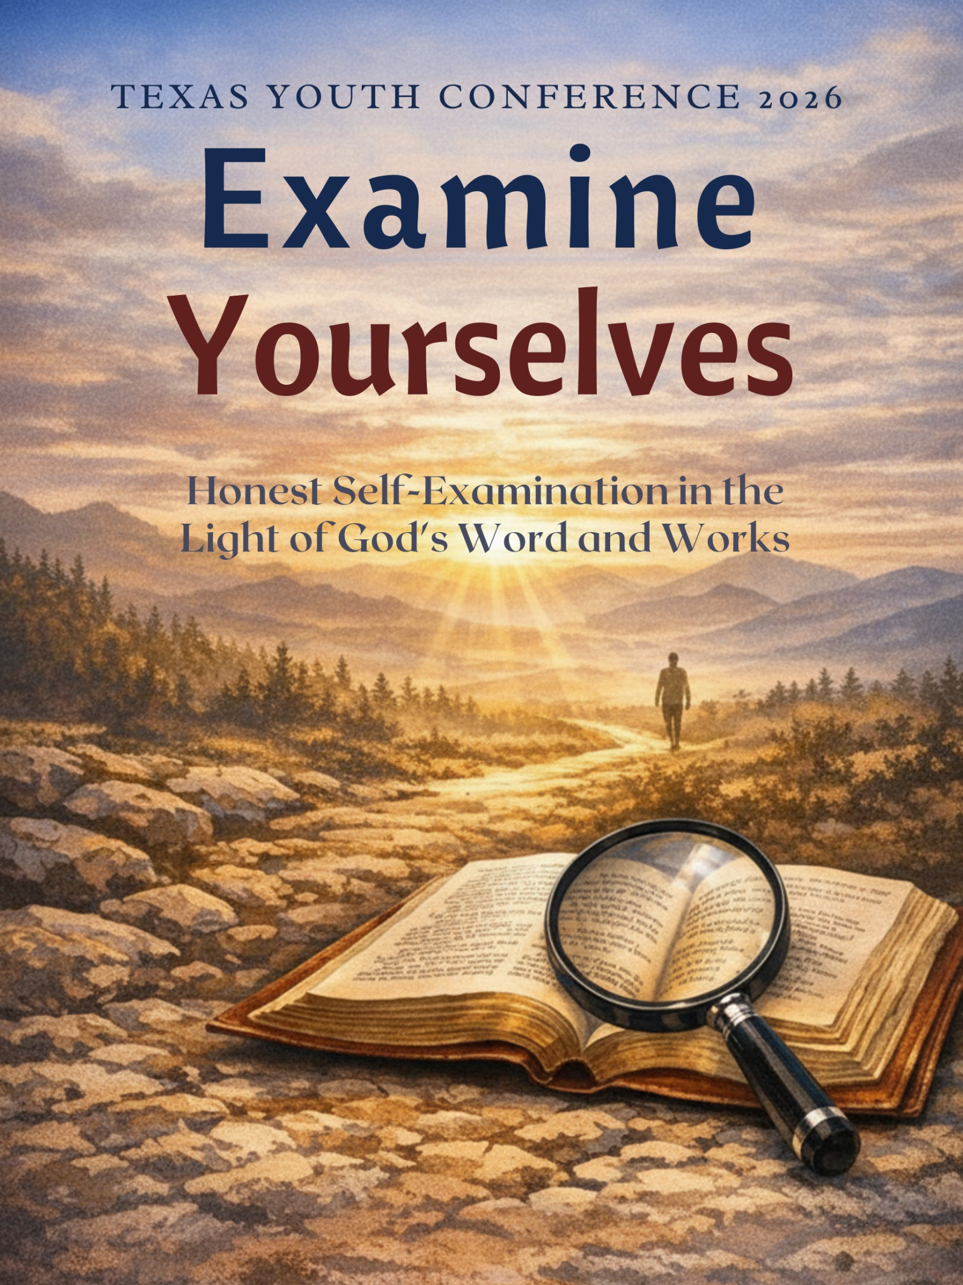

Contents
Preface
How to Use This Workbook
Recommended Resources
Day 1 — The Call to Honest Self-Examination
Day 2 — Understanding Sin and Learning to Call It Out
Day 3 — Avoiding a Pharisee’s Look
Day 4 — Tools God Gives Us for Self-Examination
Day 5 — But Let a Man Examine Himself
Conclusion
Final Pages — Notes, Commitments & Favorite Verses

Preface
Dear Young Brothers and Sisters in Christ,
Welcome to this workbook, born out of a deep desire to help us all answer the apostle Paul’s urgent call: “Examine yourselves, whether ye be in the faith; prove your own selves” (2 Corinthians 13:5).
In this workbook we will journey together through four vital themes:
- What it really means to honestly examine our hearts before God,
- The true nature of sin and how subtly it deceives us,
- The danger of a Pharisaical spirit that sees faults in others while ignoring our own.
- The practical tools God has given us—His Word, trials, humility, silence, and the pursuit of God manifestation—to grow into the character He desires.
These studies are not meant to discourage, but to encourage and equip us. We are young people living in a world that has normalized sin and blurred the goalposts of righteousness. Yet our calling remains unchanged: to walk in the light as He is in the light, to put sin to death, and to let the Spirit of Christ shape us day by day. This workbook will remind us, God manifestation—not human salvation—is the grand purpose of our lives (“Elpis Israel”).
May this workbook be more than notes on a page. May it become a mirror in which we repeatedly and honestly behold ourselves in the perfect law of liberty (James 1:23-25). Take time with each section. Answer the questions prayerfully. Discuss them with one another. Most of all, bring your honest heart before the Father who already knows us completely and loves us still.
Let us press on together toward the mark, “forgetting those things which are behind, and reaching forth unto those things which are before” (Philippians 3:13-14), so that when the Lord Jesus returns we may be found ready — transformed by His grace and reflecting His character.
To God be the glory, both now and in the Kingdom soon to come.
Your brother in the hope of Israel,
Tim Cooper

How to Use This Workbook
Welcome! This workbook is written so you can study with just your Bible and concordance.
Each day includes:
- A memory verse
- Key Bible passages
- Short explanations to help you understand the meaning
- Bible study questions that guide you through the scriptures
- Personal reflection space
- Discussion questions for your group

Our Goal
To develop the lifelong habit of honest self-examination before God so we can walk in the light, receive forgiveness, and manifest His character in our daily lives – to allow the study and honest reflection to shape our lives.

Take your time. Pray before you begin each day. Be honest with yourself and with God.

Recommended Resources
For Those Who Want to Dig Deeper
These Bible study tools and Christadelphian books will help you continue growing in honest self-examination, understanding sin, God manifestation, and patience through providence. All are faithful to Scripture and the foundational teachings of the Brotherhood.

Bible Study Tools
- Strong’s Exhaustive Concordance (with Hebrew & Greek Dictionary). Essential for studying key words such as “examine,” “prove,” “sin,” and “mind.” Helps you dig into the original meaning of verses.
- Vine’s Expository Dictionary of Old and New Testament Words. Gives clear explanations of important biblical terms related to sin, the heart, repentance, and self-examination.
- Interlinear Bible (Hebrew/Greek/English). Allows you to see the original languages alongside the English text — very helpful for passages like Romans 8, Psalm 51, and Hebrews 4.

Christadelphian-Authored Books
- The Wonder of Forgiveness — David Bailey. Deeply encouraging and practical on true repentance, forgiveness, and avoiding the “easy forgiveness” mindset.
- Be Ye Transformed (Volumes 1 & 2) — G. V. Growcott. Excellent practical help on self-examination, adding to your faith (2 Peter 1), and daily character transformation.
- Principles and Proverbs — Islip Collyer. Powerful on honest self-examination, the deceitfulness of sin, and avoiding a pharisaical spirit.
- Elpis Israel — John Thomas. Foundational teaching on human nature, sin, the Fall, and the purpose of God manifestation (especially good after Days 1–2).
- The Ways of Providence — Robert Roberts. The best book to go deeper on God’s invisible hand, patience, and how the Lord works in the lives of believers (especially helpful after Day 5).

Suggestion for Students
Start with The Wonder of Forgiveness (section on Examination specifically, though the whole book is wonderful!) and Be Ye Transformed if you’re not sure where to begin. These books will strengthen the work we started together this week and help you develop a lifelong habit of walking in the light before God. Close your group time everyday by praying for one another — that God would help each of us examine ourselves honestly and walk faithfully before Him!

Day 1 — The Call to Honest Self-Examination

Memory Verse
“Examine yourselves, whether ye be in the faith; prove your own selves. Know ye not your own selves, how that Jesus Christ is in you, except ye be reprobates?” — 2 Corinthians 13:5

A Thought to Begin
It is easy to glance in a mirror, notice something that needs fixing, and then walk away and forget. God’s Word is a perfect mirror for our souls. Today we are invited to slow down, open our Bibles, and honestly ask the Lord: “What do You see when You look at my heart?” We need to ask ourselves this question as well.

Key Readings
- 2 Corinthians 13:5
- 1 John 1:6–10
- James 1:21–25
- Psalm 139:23–24

Bible Study & Reflection Questions
- Read 2 Corinthians 13:5 carefully. What two clear actions does Paul command us to take? Why do you think this is so important for every believer? What is the connection with Galatians 6:3-5, and Romans 14:12 in this verse?

- How do we practically do this examination?

- In 1 John 1:8, what serious danger comes if we say we have no sin? What wonderful promise does God give us in verse 9? What sense do we get from the verse saying, ‘the Truth is not in us?’

- Read James 1:23–25. Describe in your own words the two different men and their different characteristics, who look into the mirror. Which one describes you more accurately right now and why?

- What does James mean by “the perfect law of liberty”? How can God’s law actually bring freedom instead of bondage?

- Turn Psalm 139:23–24 into your own personal prayer, in your own words. Write it out below.

- Do we ask God to examine us currently in our prayer life? Why or why not?

- Read 1 John 1:7. What two great blessings come to those who “walk in the light”? How do we know if we are in the light? Consider beliefs & actions.

- In 1 John 3:19–20, our hearts may condemn us — but why is it encouraging that “God is greater than our heart”? Consider 1 Corinthians 4:4 as well.

- Why do you think honest self-examination is so closely connected to experiencing God’s forgiveness?

- Using your concordance, find at least three other verse that speaks about examining, proving, or searching our own ways. Clearly write what other insights we can gain from these verses?

- Of all the verses today, which one brings you the most comfort or challenge? Why?

Personal Reflection
Take a quiet moment right now. Ask the Lord to search your heart. Write a short prayer below.

Discussion Questions for Your Group
- What makes honest self-examination difficult in everyday life?

- Share a time (without naming others) when God’s Word clearly showed you something that needed to change.

- How can we encourage one another to keep “walking in the light”?

- Which verse from today gives you the most hope about forgiveness?

- What is one practical step you will take this week to build the habit of regular self-examination?

- What personal daily reminders can we use to remind ourselves to examine our lives ,our motives, our attitudes, our direction in life?

Day 2 — Understanding Sin and Learning to Call It Out

Memory Verse
“Against thee, thee only, have I sinned, and done this evil in thy sight.” — Psalm 51:4

A Thought to Begin
Sin is far more than “making mistakes.” It is anything that goes against God’s holy character. The encouraging truth is that when we are willing to call sin what it really is, our loving Father is ready to forgive and cleanse us.

Key Readings
- Romans 8:5–8
- Genesis 3:1–13
- James 4:17
- Romans 14:23
- Matthew 5:21–28

Bible Study & Reflection Questions
- Read Romans 8:5–8. How many times does the idea of “setting the mind” appear? What are the two possible outcomes?

- In Genesis 3:7–10, what new awareness (ability to examine) and emotions did Adam and Eve experience right after they sinned? How did this change their relationship with God?

- Psalm 51:4 — Even though David had sinned greatly against other people, why did he say his sin was against God only? What perspective does this give us today when we sin, or others sin against us?
Underline in your Bible:
V4 “against thee only have I sinned” – Sin is against God / Realization
V5 “I was shapen in iniquity” – Sinful Nature
V6 “truth in inward parts” – Examination
V7 “I shall be clean” – Washing of Sin/Cleansing
V10 “right spirit”

- Read James 4:17. What is the sin of omission? Can you think of a good thing you know you should be doing but have been neglecting? Find other verses that correspond to this verse.

- In Matthew 5:21–28, how does Jesus show that sin begins in the heart and mind before any outward action? How does this highlight the importance of self-examination considering we alone know our thoughts?

- Read 1 John 2:16 along with Genesis 3:6. What three types of desire are mentioned? Were these desires evil when God first gave them?

- Why is it often easier to excuse sin in our own lives than to call it out clearly?

- Titus 1:15 — To those who are defiled, why is nothing pure? Have you ever seen a defiled mind at work? Why are we so willing to call out sin in someone else’s lives while we struggle with the same issue? What lesson did you learn from examining that person’s life and actions?

- Using your concordance, look up the word “sin” and copy three verse that shows how deceitful sin can be.

Personal Reflection
Be honest with God right now. Is there any sin you have been excusing or calling by a softer name, to feel better about it? Write a short prayer bringing it into the light, and seek forgiveness!

Discussion Questions for Your Group
- How does remembering that all sin is ultimately against God change the way we treat one another?

- Share an area (without too much detail) where your thoughts or motives revealed sin even when your outward actions looked fine.

- How can we help each other call sin what it is in a gentle, loving way?

- What is one good thing you know the Lord wants you to do that you have been putting off?

- This week, what is one specific sin or habit you will consciously call out and seek to replace with God’s Word? (You can keep this private, if you choose!)

- Why do we not use the confessional booth as Christadelphians? What are pros and cons of this practice, is it a scriptural principle we should be doing?

- Many times we measure our spiritual lives against the worlds standards. How is this dangerous, and what standards should we be measuring against?

- You cannot fix a problem that you do not admit you have. Honestly list 5 things that you need to fix in your spiritual life. (You can keep this private, if you choose!)

Day 3 — Avoiding a Pharisee’s Look

Memory Verse
“Thou hypocrite, first cast out the beam out of thine own eye …” — Matthew 7:5

A Thought to Begin
It is very natural for us to see small faults in others while missing much larger issues in ourselves. Jesus gives us a strong warning against this self-righteous attitude.

Key Readings
- Romans 2:1–3
- Matthew 7:1–5
- Luke 18:9–14
- Matthew 19:16–22

Bible Study & Reflection Questions
- Read Romans 2:1–3. Why does the Bible say that when we judge another person we condemn ourselves? Find 2 other verses that support this sentiment in Scripture.

- Explain the illustration of the mote and the beam in Matthew 7:3–5 in your own words. Give an example of how this can happen in the ecclesia today.

- In Luke 18:9–14, what was the Pharisee thankful for, and what was the Publican’s prayer? Who went home justified? What character must we show in our lives if we are to be justified in the end? Find 2 other bible verses that support this theme.

- Read Matthew 19:16–22. The rich young ruler thought he had kept the commandments. What deeper heart issue did Jesus expose? Can we lie to ourselves in this same way? What is something in your spiritual life that you are blind to, or not readily willing to admit?

- Proverbs 16:2 says “All the ways of a man are clean in his own eyes.” What does this reveal about human nature?

- Why is it spiritually dangerous to compare our walk with that of other believers?

Personal Reflection
Write the Publican’s prayer (“God be merciful to me a sinner”) in your own words and make it your prayer today.

Discussion Questions for Your Group
- When have you caught yourself focusing on someone else’s small fault while ignoring a larger one in your own life?

- How can we lovingly help a struggling brother or sister while first removing our own beam? Provide a practical description of how you would do this.

- What would change in our groups and ecclesia if we all approached one another with the Publican’s humble spirit?

- How does remembering that we all share the same sinful nature help us stay humble?

- During TYC, when you notice a fault in someone else, what will you do first, or differently?

- How can we balance honest concern for others with genuine humility? List 5 practical ways we can do this.

- Share one practical way you will guard against a self-righteous attitude.

- How does true humility open the door to greater forgiveness in our own lives?

- What is one thing you will do differently this week because of today’s study?

Day 4 — Tools God Gives Us for Self-Examination

Memory Verse
“Let us search and try our ways, and turn again to the LORD.” — Lamentations 3:40

A Thought to Begin
God has not left us to examine ourselves without help. He gives us clear tools in His Word to search our hearts and grow in godliness.

Key Readings
- Hebrews 4:12–13
- Philippians 3:13–14
- Hebrews 12:1
- 2 Peter 1:5–8
- Psalm 4:4

Bible Study & Reflection Questions
- Hebrews 4:12 — What four powerful descriptions are given about the Word of God? We get the sense of having a surgery and our inward parts being inspected. Read also Leviticus 1:3-6. Find the connection with Christ. How are we to connect wit the offering? Where does the examination take place?

- Philippians 3:13–14 — What does Paul choose to do with past failures so he can move forward? How good are you at doing the same in your life?

- Hebrews 12:1 — What is the difference between a “weight” and a “sin which doth so easily beset us”? What practical lesson can we learn to apply to our lives based on this?

- Read 2 Peter 1:5–8. List the qualities we are told to add to our faith. Why are they important? How can we tell if these qualities are in our character?

- Psalm 4:4 — What does it mean to “commune with your own heart upon your bed, and be still”? Why is this such a challenge in today’s age?

- How can trials become one of God’s tools for examining and refining us? What does this teach us about trails, and how we look at them in our lives?

- Using your concordance, find one verse about each of the following tool for examination: the Word of God, trials, humility, and silence. Mention how the verse teaches us to use this tool while examining our lives?

Personal Reflection
Write three realistic spiritual goals: one for this week, one for this month, and one for this year. Also create a realistic plan to track this goal on a regular basis!

Discussion Questions for Your Group
- Which tool do you most need to use most in a given week?

- What “weight” is currently slowing your spiritual progress? How can you lay it aside?

- How can we create more moments of silence for honest self-examination – practically plan time?

- Consider one of the goals you wrote earlier and think why it matters.

- How does using these tools help us manifest God’s character in daily life?

- What is one way God’s Word has recently shown you something that needed attention in our lives?

- How can we encourage each other to use these tools consistently?

- How does faithful self-examination prepare us for the coming of Christ?

Day 5 — Examining our Spiritual Lives in Light of Partaking in the Emblems and Living a Life of Service to God

Memory Verse
“Wherefore whosoever shall eat this bread nad drink this cup of the Lord, unworthily, shall be guilty of the body and blood of the Lord. But let a man examine himself, and so let him eat of that bread, and drink of that cup.”
— 1 Corinthians 11:27-29

A Thought to Begin
God often works in quiet, unseen ways. Learning patience while we examine ourselves is one of the most important lessons in the Christian life.

Key Readings
- Genesis 3:7-10
- Genesis 4:7
- 1 Corinthians 11
- Lamentations 3:40
- James 4:8
- Jeremiah 17:9

Bible Study & Reflection Questions

- Read 1 Corinthians 11:27-32. Paul says we must “examine ourselves” before partaking of the bread and cup.
  - What does the word “examine” seem to mean in this context? (Hint: look up the idea of testing something for genuineness.)

  - Why is proper self-examination so important according to verses 29-32?

  - How does this warning connect to our own Memorial Meeting each week?

- Two important things to highlight are joy and peace as important things to check in our own lives. Read the following verses: Romans 5:3, Philippians 4:4, 1 Peter 1:8, Psalm 32:11, Romans 8:6, Colossians 3:15.
  - What do these verses teach us about the kind of joy and peace God wants His people to have?

  - Why might it be easier to fake joy and peace on the outside (especially on social media) than to actually possess them?

  - Honestly ask yourself: Do I have this kind of joy and peace right now, even when things are hard? What is one thing that might be robbing me of it?

- Read Jeremiah 17:9-10.
  - What does God say about the human heart?

  - What does it mean that God “searches the heart” and “tries the reins” (kidneys = innermost thoughts and motives)?

  - Why is it dangerous to only examine ourselves on the surface? What does God see that we often try to hide?

- In moments of leisure or relaxation, do we turn to natural pleasures or to the Word of God? Read 2 Corinthians 6:16-18 and think about the call to “cleanse ourselves from all defilement” and “perfect holiness in the fear of the Lord.”
  - What does this look like in everyday life (school, phone use, free time, friendships)?

  - If someone watched how you spend your free time this week, would they see a “consuming devotion” to the things of God?

  - What is one small, practical change you could make this week to show that devotion?

- Think about Bible characters who faced their sins honestly and changed (Judah, Manasseh, Paul) versus those who saw their sin but would not humble themselves (Cain, Saul, Judas). Read 2 Corinthians 13:5 (“Examine yourselves, whether ye be in the faith…”) and Galatians 6:3-4.
  - What is the difference between surface-level religion and genuine heart felt examination?

  - As you prepare to partake of the emblems each week, what is one area of your life you need to bring honestly before God right now?

  - Write a short prayer asking God to help you with “cleansing yourself” and walking in the light as you remember Christ’s sacrifice.

Personal Reflection
Looking back over the entire book, write a short covenant with God about your commitment to honest, ongoing self-examination and in your life.

Discussion Questions for Your Group

- What has been the most important lesson you learned this week about self-examination?

- How can daily self-examination help us trust God’s invisible hand?

- What is one practical change you plan to make moving forward?

- How has this study strengthened your hope in the Kingdom of God?

- How can we support one another while we wait for the Lord’s return?

- What does “manifesting God” mean to you personally after completing this workbook?

- Share one way you have seen (or hope to see) God working all things for good in our lives?

- Romans 8:28 — To whom does this promise apply? What comfort does it give us?

- Isaiah 40:31 — What blessings are promised to those who wait upon the Lord?

Conclusion
As we come to the end of this workbook, we pray that the Lord has used these studies to stir within each of us a deeper, more honest desire to examine ourselves in the light of His holy Word. We have looked squarely at the deceitfulness of sin, confronted the subtle danger of a Pharisaical spirit, and been given practical tools—Scripture, trials, humility, silence, and the pursuit of God manifestation—to help us walk more faithfully in the narrow way.
None of us have “arrived.” We are all, like the apostle Paul, pressing toward the mark, forgetting what lies behind and reaching forward to what lies ahead (Philippians 3:13-14). The journey requires daily honesty, continual repentance, and patient trust in the invisible hand of our loving Father who works all things for the good of those who love Him (Romans 8:28).
May these classes not simply fill our minds with knowledge, but transform our hearts and lives. Let the mirror of God’s Word remain in our hands. Let us regularly ask ourselves the hard questions, remove every weight and sin that so easily besets us, and replace the old ways with virtue, knowledge, temperance, patience, godliness, brotherly kindness, and charity (2 Peter 1:5-8). Above all, let us fix our eyes on the grand purpose of our calling—God manifestation—so that when the Lord Jesus Christ returns, He will find in us a people who reflect something of His own beautiful character. As you leave these pages, carry with you the words of the hymn we often sing:
“When we think how much our Father, Has forgiven and does forgive,
Brethren we should learn the rather, Free from wrath and strife to live…”
Let us therefore examine ourselves every time we come to the memorial table, partaking worthily, in humble gratitude for the cleansing blood of our Saviour. And let us wait with patient, joyful expectation for the day when “we shall be like him, for we shall see him as he is” (1 John 3:2). May the God of all grace strengthen, establish, and settle you in this most precious hope. To Him be glory in the ecclesia and in Christ Jesus, throughout all ages, world without end. Amen.
Your brother in the Lord Jesus Christ,
Tim Cooper

Final Pages
Use the following pages to record your continuing reflections, commitments, and favorite verses from this study.

Notes & Journaling

My Commitments to the Lord

Favorite Verses from the Week

